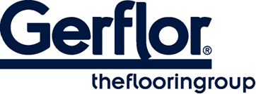 GTI MAX cleantech

GTI MAX CLEANTECH is a multi-layered loose lay vinyl tile with polyurethane treatment (PUR+), 6 mm thick with welded joints, abrasion group T. It is manufactured by GERFLOR using a continuous high pressure process.

GTI MAX CLEANTECH wear layer is reinforced by specific oblong fillers that offers an outstanding resistance to traffic.

GTI MAX CLEANTECH is reinforced with 2 glass fiber grids on either side of an intermediate pressed homogeneous layer.
GTI’s backing is a 4 mm thick black pressed homogeneous sheet, its surface is a colored and reinforced homogeneous sheet 2 mm thick.

It is made of 100% controlled recycled materials.
It is 100% recyclable and made with up to 80% recycled content.

